SIMATS ENGINEERING
ASSESSMENT TOOL 3

COURSE NAME: COMPUTER NETWORKS
COURSE CODE: CSA07

COURSE OUTCOME COVERED

CO4:
Design network topologies star, mesh, bus, and hybrid using networking devices, transmission media, and cabling standards
(BL2,BL6)

Assessment Tool Weightage: 30%

QUESTIONS: 5 Total Marks:25

Annexure A

Comparative Analysis

Code of Conduct:

I _M.V.PREETHASHRI(192524476)_ (Name / Reg No) certify that this submission is my original work and that I have adhered to the guidelines specified for this assessment.
I understand that any violation of academic integrity rules will result in disciplinary action.

Signature of the student: M.V.PREETHASHRI

Annexure A

Comparative Analysis
- Star topology is generally more expensive than bus topology because it requires a central device such as a switch or hub and more cabling to connect each node individually. In contrast, bus topology uses a single backbone cable, making it low-cost and easier to install. However, in terms of reliability, star topology is superior because failure of one node does not affect others, whereas a failure in the main bus cable can bring down the entire network. Performance is also better in star topology since data transmission is managed through a central device, reducing collisions, while bus topology suffers from performance degradation as more devices are added due to increased data traffic on the shared medium.
ANSWER:
Comparison of Star Topology and Bus Topology
Star topology is generally more expensive than bus topology because it requires a central networking device, such as a switch or hub, and separate cables to connect each device to the central device. In contrast, bus topology uses a single backbone cable to connect all the devices, making it cheaper and easier to install.
In terms of cost, bus topology is more economical because it requires less cable and does not need a central switch or hub. However, star topology requires individual cables from every node to the central device, increasing installation and maintenance costs.
In terms of reliability, star topology is superior. If one computer or one connecting cable fails, only that particular device is affected, while the rest of the network continues to operate normally. In bus topology, all devices depend on the main backbone cable. If the backbone cable fails or is damaged, the entire network may stop working.
Regarding performance, star topology provides better performance because the central switch manages communication between devices. Modern switches can send data directly to the intended device, reducing unnecessary traffic and collisions. In bus topology, all devices share the same communication channel. As more devices are connected, network traffic increases, which can lead to more collisions and reduced performance.
Star topology is also easier to troubleshoot and maintain. Since each device has a separate connection to the central switch, a network administrator can easily identify which cable or device has a problem. In bus topology, finding a fault in the backbone cable can be more difficult because a single fault may affect the entire network.
In terms of scalability, star topology is better because new devices can be added easily by connecting them to an available port on the switch. In bus topology, adding more devices increases traffic on the shared backbone and may reduce network efficiency.

Therefore, bus topology is cheaper and simpler, making it suitable for small or temporary networks. Star topology is more expensive but provides better reliability, performance, scalability, and easier maintenance. For modern computer networks, star topology is generally preferred because of its advantages and because switches provide efficient communication between connected devices.
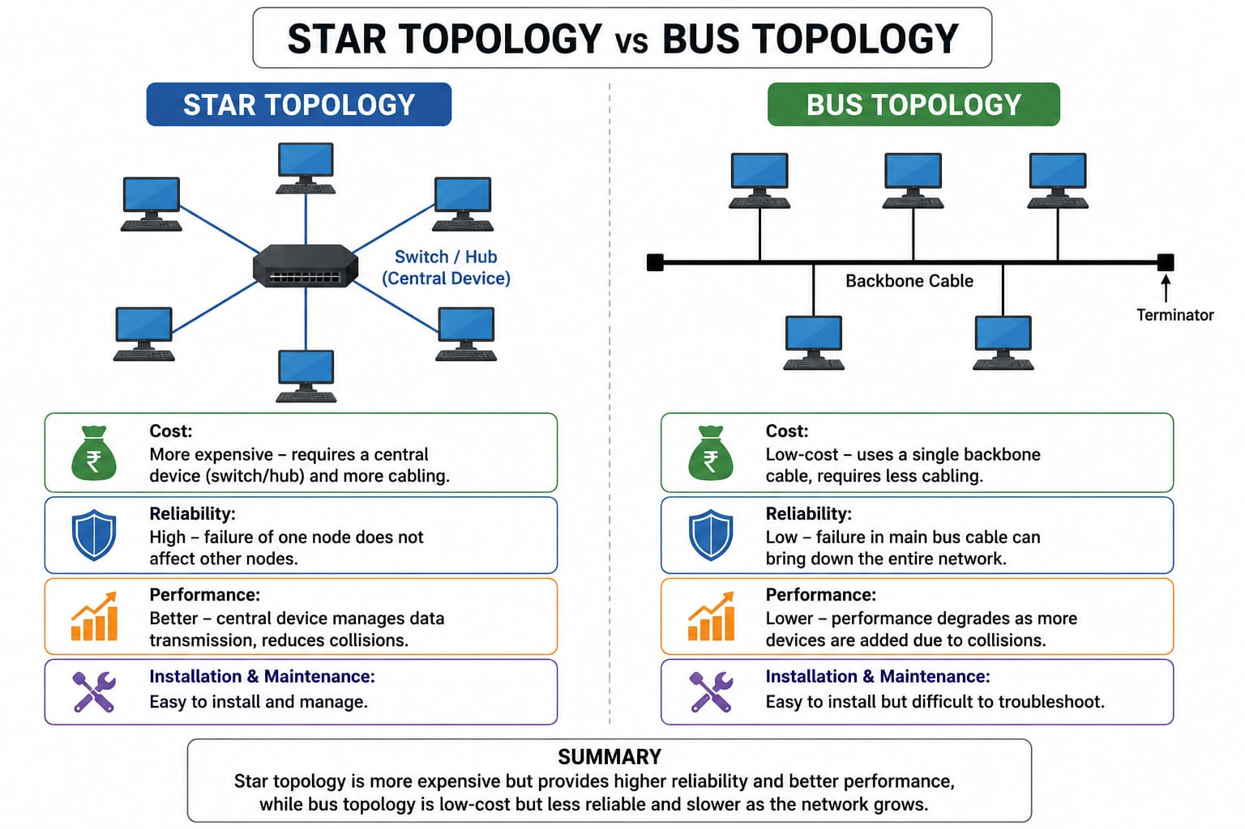

- Mesh topology offers very high fault tolerance because every node is connected to multiple other nodes, providing multiple paths for data transmission. If one link fails, data can still be routed through alternate paths without disrupting communication. In contrast, star topology has moderate fault tolerance; while failure of individual nodes does not affect the network, failure of the central hub or switch can cause the entire network to stop functioning. Therefore, mesh topology is more robust and reliable in critical environments compared to star topology.

ANSWER:
Mesh Topology vs Star Topology
Mesh topology offers very high fault tolerance and reliability because every node is connected to multiple other nodes. This creates multiple paths for data transmission between devices. If one connection or link fails, data can still be transmitted through an alternative path without interrupting the communication. Therefore, the failure of a single link does not usually affect the entire network.
In contrast, star topology provides moderate fault tolerance because all devices are connected to a central device such as a hub or switch. If one individual device or its connecting cable fails, the other devices can continue to communicate normally. However, if the central hub or switch fails, communication between all connected devices may be disrupted, causing the entire network to stop functioning.
Mesh topology is therefore more robust and reliable than star topology, especially in critical environments where continuous communication is important. However, mesh topology requires more cables, ports, and installation costs because of the large number of connections.
Mesh topology provides higher fault tolerance because it has multiple communication paths, while star topology depends on a central device. Hence, mesh topology is more suitable for critical networks requiring high reliability and minimum network downtime.
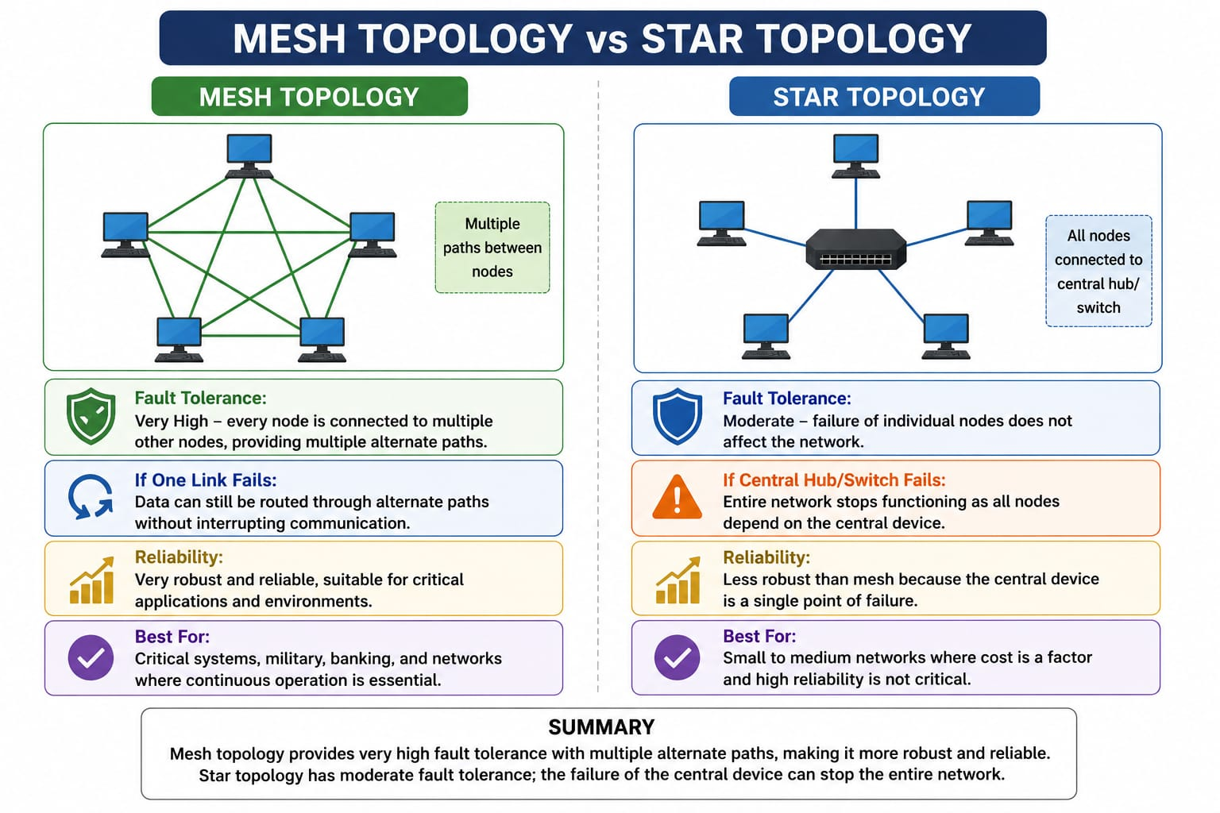
- Bus topology is simple and easy to install because it uses a single backbone cable with minimal connections, making it suitable for small networks. On the other hand, mesh topology is highly complex to install as each node must be connected to every other node, requiring a large number of cables and ports. This complexity increases significantly as the number of devices grows, making mesh topology time-consuming and costly to implement compared to the straightforward setup of bus topology.
ANSWER:
Bus Topology and Mesh Topology – Installation Complexity
Bus topology is simple and easy to install because all the devices are connected to a single main cable called the backbone cable. It requires fewer cables and connections compared to other network topologies. There is no need for a central switch or hub, which reduces the installation cost and makes the network easier to set up. Because of its simple structure, bus topology is suitable for small networks where only a limited number of devices need to be connected.
Another advantage of bus topology is that it requires less physical space and fewer networking components. Devices can be connected to the main backbone cable using appropriate connectors. This makes the installation process relatively quick and straightforward. However, the backbone cable must be properly terminated at both ends to prevent signal reflection and communication problems. If the backbone cable is damaged, the communication of the entire network may be affected.
On the other hand, mesh topology is much more complex to install. In a full mesh topology, every device is directly connected to every other device. Therefore, a large number of cables and network ports are required. As the number of devices increases, the number of connections also increases rapidly. This makes mesh topology more difficult and expensive to install than bus topology.
For example, if there are only a few devices, establishing a mesh network may be manageable. However, when many devices are added, maintaining individual connections between them becomes complicated. More cables, ports, networking equipment, and physical space are required. Therefore, the installation process becomes time-consuming, costly, and difficult to manage.
Despite its complexity, mesh topology provides an important advantage: high reliability and fault tolerance. Since there are multiple paths between devices, if one connection fails, data can travel through another available path. Thus, a single cable failure does not normally bring down the entire network. This makes mesh topology suitable for critical networks where continuous communication is important.
Bus topology, in comparison, is less expensive and easier to maintain, but it has limited fault tolerance. If the main backbone cable fails, communication across the network can be disrupted. Therefore, while bus topology is better in terms of simplicity and installation cost, mesh topology is better in terms of reliability and redundancy.
Bus topology is simple, economical, and easy to install, making it suitable for small and less complex networks. Mesh topology is more complex, expensive, and time-consuming to install because it requires multiple connections between devices. However, mesh topology provides higher reliability, redundancy, and fault tolerance. Therefore, the choice between them depends on whether the priority is low installation cost and simplicity or high reliability and network availability.
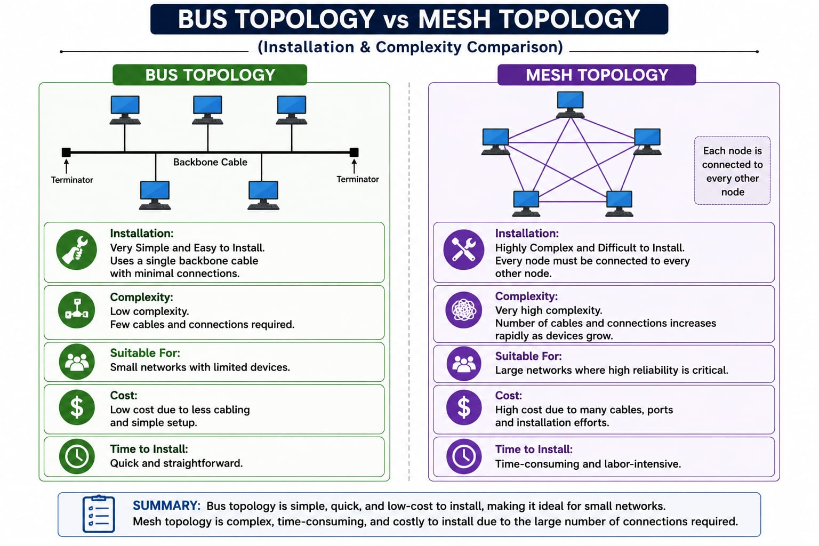

- Hybrid topology is highly scalable because it combines two or more different topologies (such as star, mesh, or bus), allowing the network to expand flexibly according to organizational needs. New segments can be added without affecting the existing network structure. In comparison, star topology is also scalable but to a limited extent, as it depends on the capacity of the central device (switch or hub). Once the central device reaches its port limit, expansion requires additional hardware. Thus, hybrid topology provides greater scalability than star topology.
ANSWER:
Hybrid Topology and Star Topology – Scalability
Hybrid topology is considered highly scalable because it combines two or more different network topologies, such as star, bus, ring, or mesh, into a single network. This flexible structure allows an organization to expand its network according to its requirements. New network segments can be added without completely changing the existing network structure. For example, a company can use star topology in one department and connect it with another department using a different topology. This makes hybrid topology suitable for large organizations and growing networks.
One of the major advantages of hybrid topology is its flexibility. Different sections of a network can be designed according to their specific requirements. When a new department, building, or group of computers needs to be added, a new network segment can be connected to the existing infrastructure. This allows the network to grow gradually while reducing the need to redesign the entire network.
In comparison, star topology also provides good scalability, because new devices can be connected to the central switch or hub. However, its scalability is limited by the number of available ports and capacity of the central device. When all the ports of the switch or hub are occupied, additional hardware such as another switch is required to connect more devices. Therefore, expansion may involve additional equipment and configuration.
Hybrid topology provides greater scalability because different network sections can use different topologies based on their requirements. It can support a large number of devices and departments while maintaining a structured network design. However, hybrid topology can be more expensive and complex to design and manage because it combines multiple topologies and may require different networking devices.
Both hybrid and star topologies are scalable, but hybrid topology provides greater flexibility and scalability. Star topology is suitable for small and medium-sized networks, while hybrid topology is more suitable for large organizations, campuses, and networks that need continuous expansion. Therefore, hybrid topology is preferred when flexibility, expansion, and long-term scalability are important.
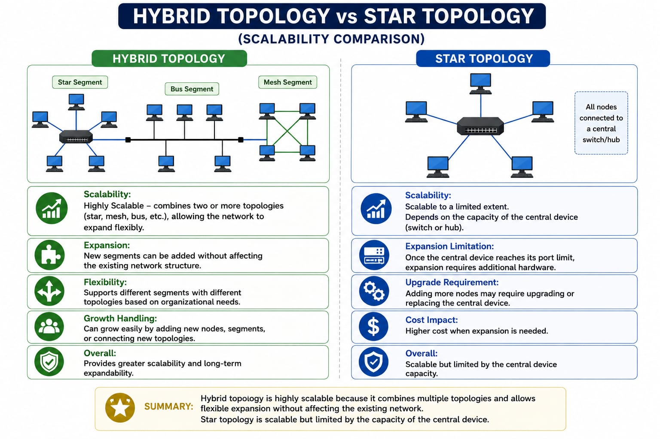

- In terms of maintenance, star topology is relatively easy to manage because issues can be quickly identified and isolated to a specific node or cable. Mesh topology, while highly reliable, is difficult to maintain due to its complex structure and large number of connections, making troubleshooting time-consuming. Bus topology is harder to maintain than star because faults in the backbone cable can disrupt the entire network and are difficult to locate. Hybrid topology has moderate maintenance complexity; while it benefits from flexibility, managing multiple combined topologies requires careful monitoring and skilled administration.
ANSWER:
Maintenance of Star, Mesh, Bus, and Hybrid Topologies
In terms of maintenance, star topology is relatively easy to manage because each device is connected separately to a central switch or hub. If a problem occurs, the faulty device or cable can be easily identified and isolated without affecting the other devices. This makes troubleshooting and maintenance faster and simpler. Even if one node fails, the remaining devices can continue to communicate normally.
Mesh topology, although highly reliable and fault-tolerant, is more difficult to maintain because of its complex structure and large number of connections. Since many devices are connected through multiple links, identifying and repairing a faulty connection can be time-consuming. It also requires skilled network administrators and more maintenance resources. However, its multiple paths provide better reliability when a link fails.
Bus topology is harder to maintain than star topology because all devices share a common backbone cable. If the backbone cable develops a fault, communication across the entire network may be disrupted. Locating the exact point of failure can be difficult because many devices depend on the same cable. As a result, troubleshooting can take more time, especially in larger networks.
Hybrid topology has moderate maintenance complexity because it combines two or more different topologies, such as star, bus, or mesh. Its flexible structure makes it possible to manage different sections separately, but administrators need to understand and monitor each type of topology used in the network. This requires proper planning, regular monitoring, and skilled administration.
Therefore, star topology is the easiest to maintain, while mesh topology is the most complex because of its numerous connections. Bus topology is difficult to troubleshoot when the backbone fails, while hybrid topology requires moderate maintenance due to its combination of different network structures. Overall, the choice of topology depends on the organization's requirements for reliability, cost, scalability, and ease of maintenance.
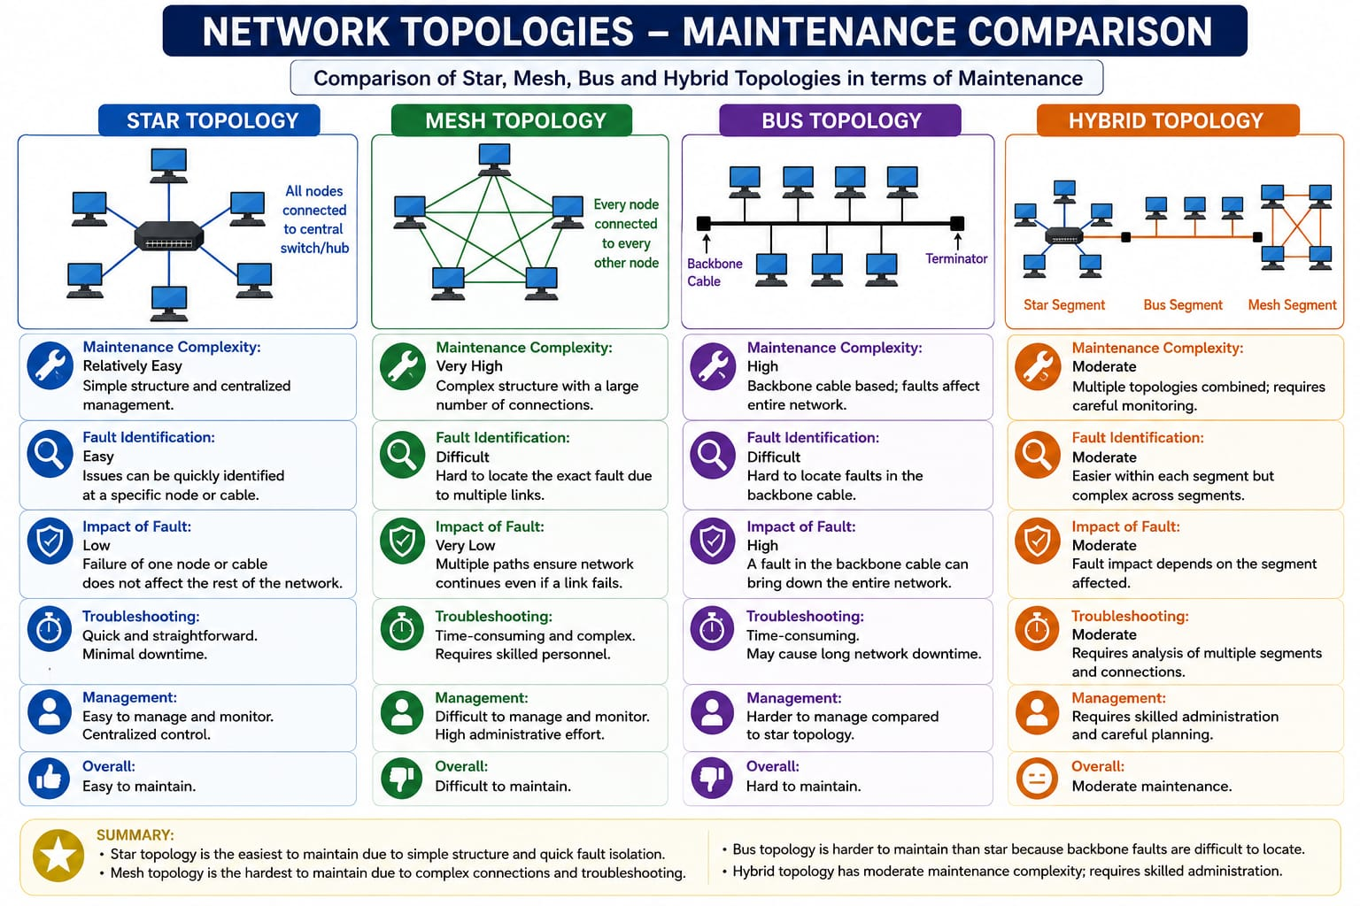

RUBRICS FOR CALCULATION

Criteria | Weightage | Exemplary (4) | Proficient (3) | Developing (2) | Beginning (1)
Understanding of Concepts | 15% | Demonstrates complete and in-depth understanding of all concepts being compared | Good understanding with minor gaps | Basic understanding; some concepts unclear | Poor understanding of concepts
Comparison Depth | 20% | Provides detailed, insightful, and meaningful comparisons across multiple aspects | Adequate comparison with relevant points | Limited comparison; lacks depth | Minimal or incorrect comparison
Criteria Selection | 10% | Selects highly relevant and appropriate comparison parameters | Mostly relevant criteria | Some irrelevant or missing criteria | Poor or no criteria selection
Analytical Skills | 15% | Strong analysis with logical reasoning and clear justification | Good analysis with some justification | Basic analysis with weak reasoning | No clear analysis
Organization & Structure | 10% | Well-organized, clear, and logically structured | Generally organized | Somewhat disorganized | Poorly structured
Use of Examples / Evidence | 10% | Uses strong, relevant examples or data to support comparison | Uses some examples | Limited examples | No supporting examples
Clarity of Presentation | 10% | Very clear, concise, and easy to understand | Mostly clear | Somewhat unclear | Difficult to understand
Conclusion & Insights | 10% | Insightful conclusion with strong justification | Clear conclusion | Basic conclusion | No or weak conclusion

